[Upgrade](https://medium.com/membership?source=upgrade_membership---nav_full------------------------)



[[](https://towardsdatascience.com/?source=post_page-----55f407423840----------------------)](https://towardsdatascience.com/?source=post_page-----55f407423840----------------------)

* [DATA SCIENCE](https://towardsdatascience.com/data-science/home?source=post_page-----55f407423840----------------------)
* [MACHINE LEARNING](https://towardsdatascience.com/machine-learning/home?source=post_page-----55f407423840----------------------)
* [PROGRAMMING](https://towardsdatascience.com/programming/home?source=post_page-----55f407423840----------------------)
* [VISUALIZATION](https://towardsdatascience.com/data-visualization/home?source=post_page-----55f407423840----------------------)
* [VIDEO](https://towardsdatascience.com/video/home?source=post_page-----55f407423840----------------------)
* [★](https://towardsdatascience.com/editors-picks/home?source=post_page-----55f407423840----------------------)
* [ABOUT](https://towardsdatascience.com/about-us/home?source=post_page-----55f407423840----------------------)
* [CONTRIBUTE](https://towardsdatascience.com/contribute/home?source=post_page-----55f407423840----------------------)

**Responses (8)**



Shuxue

What are your thoughts?﻿

Cancel

Respond



[André Frade](https://towardsdatascience.com/@andr.frade?source=responses-----55f407423840----0------------------)

[9 months ago](https://medium.com/@andr.frade/all-your-probability-distribution-explanations-are-amazing-78c8a67f69d3?source=responses-----55f407423840----0------------------)

All your probability distribution explanations are amazing !! The best I have found in the internet.

Would you consider making a Beta Distribution — Intuition, Derivation and Examples post ? I have been struggling to understand this one.

Thank you fo...

Read More

70

[1](https://medium.com/@andr.frade/all-your-probability-distribution-explanations-are-amazing-78c8a67f69d3?responsesOpen=true&source=responses-----55f407423840----0------------------)



[Biswajit Pattnaik ❤️🙏](https://towardsdatascience.com/@biswajit3071976?source=responses-----55f407423840----1------------------)

[3 months ago](https://medium.com/@biswajit3071976/i-have-watched-some-25-videos-on-gamma-distribution-read-multiple-books-on-gamma-n-many-webpages-edb1c901685f?source=responses-----55f407423840----1------------------)

I have watched some 25 videos on gamma distribution,read multiple books on gamma n many webpages also but nobody has explained it more lucidly than you.you just touch the fundamentals & make it so easy.pl keep writing on statistics,data science topic...

Read More

39

Jason Young

[Jason Young](https://towardsdatascience.com/@yaobviously?source=responses-----55f407423840----2------------------)

[10 months ago](https://medium.com/@yaobviously/just-terrific-thanks-de6cfe646caa?source=responses-----55f407423840----2------------------)

just terrific. thanks.

10

[1](https://medium.com/@yaobviously/just-terrific-thanks-de6cfe646caa?responsesOpen=true&source=responses-----55f407423840----2------------------)



[Buhringj](https://towardsdatascience.com/@buhringj?source=responses-----55f407423840----3------------------)

[7 months ago](https://medium.com/@buhringj/great-article-as-usual-7d0601a02316?source=responses-----55f407423840----3------------------)

Great article as usual. I am having trouble understanding the definition of the CDF. When you sum up the events from 0 to k-1, why is there a “t” in both terms of the numerator? The amounts being summed look like a Poisson formula but Poisson doesn’t...

Read More

7

[1](https://medium.com/@buhringj/great-article-as-usual-7d0601a02316?responsesOpen=true&source=responses-----55f407423840----3------------------)



[Panu Payorasisakul](https://towardsdatascience.com/@p.payorasisakul?source=responses-----55f407423840----4------------------)

[9 months ago](https://medium.com/@p.payorasisakul/amazing-thanks-1a8b40e9e884?source=responses-----55f407423840----4------------------)

Amazing, thanks

8



[Sumra Mushtaq](https://towardsdatascience.com/@sumra.mushtaq449?source=responses-----55f407423840----5------------------)

[3 months ago](https://medium.com/@sumra.mushtaq449/aerin-kim-thank-you-very-much-for-such-nice-explanation-of-gamma-distribution-e1ff84961b10?source=responses-----55f407423840----5------------------)

Aerin Kim Thank you very much for such nice explanation of gamma distribution. Could you please also share derivation of quantile of gamma distribution?



[Akshay](https://towardsdatascience.com/@ak163496?source=responses-----55f407423840----6------------------)

[about 2 months ago](https://medium.com/@ak163496/i-doubt-then-is-gamma-distribution-is-equivalent-to-erlang-distribution-9d91eb5d516e?source=responses-----55f407423840----6------------------)

I doubt then is gamma distribution is equivalent to Erlang distribution?



[Francesco Lippi](https://towardsdatascience.com/@francescolippi?source=responses-----55f407423840----7------------------)

[7 months ago](https://medium.com/@francescolippi/nice-derivation-but-let-me-warn-that-you-should-revise-your-discussion-of-shape-vs-scale-3276eeaa1789?source=responses-----55f407423840----7------------------)

Nice derivation but let me warn that you should revise your discussion of shape vs scale.

Whomever named them so was quite smart. Obviously when you change Lambda “something happens”, so that to the eye of a layman the three distributions look “diffe...

Read More

You have **2** free stories left this month.

[Upgrade for unlimited access.](https://medium.com/membership?source=upgrade_membership---post_counter--55f407423840----------------------)

Top highlight

Gamma Distribution — Intuition, Derivation, and Examples

and why does it matter?

[[](https://towardsdatascience.com/@aerinykim?source=post_page-----55f407423840----------------------)](https://towardsdatascience.com/@aerinykim?source=post_page-----55f407423840----------------------)

[Aerin Kim](https://towardsdatascience.com/@aerinykim?source=post_page-----55f407423840----------------------)

Follow

[Oct 12, 2019](https://towardsdatascience.com/gamma-distribution-intuition-derivation-and-examples-55f407423840?source=post_page-----55f407423840----------------------) · 8 min read

Before setting Gamma’s two parameters ***α, β***and plugging them into the formula, let’s pause for a moment and ask a few questions…

Why did we have to invent the Gamma distribution? (i.e., why does this distribution exist?)

When should Gamma distribution be used for modeling?

**1. Why did we invent Gamma distribution?**

**Answer: To predict the wait time until future events.**

*Hmmm ok, but I thought that’s what the exponential distribution is for.  
Then,****what’s the difference between exponential distribution and gamma distribution?***

The exponential distribution predicts the wait time until the **\*very first\*** event. The gamma distribution, on the other hand, predicts the wait time until the **\*k-th\*** event occurs.

**2. Let’s derive the PDF of Gamma from scratch!**

In our [previous post](https://towardsdatascience.com/what-is-exponential-distribution-7bdd08590e2a), we derived the PDF of exponential distribution from the Poisson process. I highly recommend learning [Poisson](https://towardsdatascience.com/poisson-distribution-intuition-and-derivation-1059aeab90d) & [Exponential](https://towardsdatascience.com/what-is-exponential-distribution-7bdd08590e2a)distribution if you haven’t already done so. Understanding them well is absolutely required for understanding the Gamma well. The order of your reading should be 1. [Poisson](https://towardsdatascience.com/poisson-distribution-intuition-and-derivation-1059aeab90d), 2. [Exponential](https://towardsdatascience.com/what-is-exponential-distribution-7bdd08590e2a), 3. Gamma.

**The derivation of the PDF of Gamma distribution is very similar to that of the exponential distribution PDF, except for one thing** — it’s the wait time until **the k-th event**, instead of **the first event**.

< Notation! >\* **T** : the random variable for **wait time until the k-th event** (This is the random variable of interest!)  
\* **Event arrivals are modeled by a Poisson process with rate λ.**\* **k** : the 1st parameter of Gamma. **The # of events** for which you are waiting.  
\* **λ** : the 2nd parameter of Gamma. **The rate of events** happening which follows the Poisson process.\* **P(T > t) :** The probability that the waiting time until the **k**-th event is greater than **t** time units  
\* **P(X = k in t time units) :** The Poisson probability of **k** events occuring during **t** time units

[As usual](https://towardsdatascience.com/what-is-exponential-distribution-7bdd08590e2a), in order to get the PDF, we will first find the CDF and then differentiate it.

Image for post

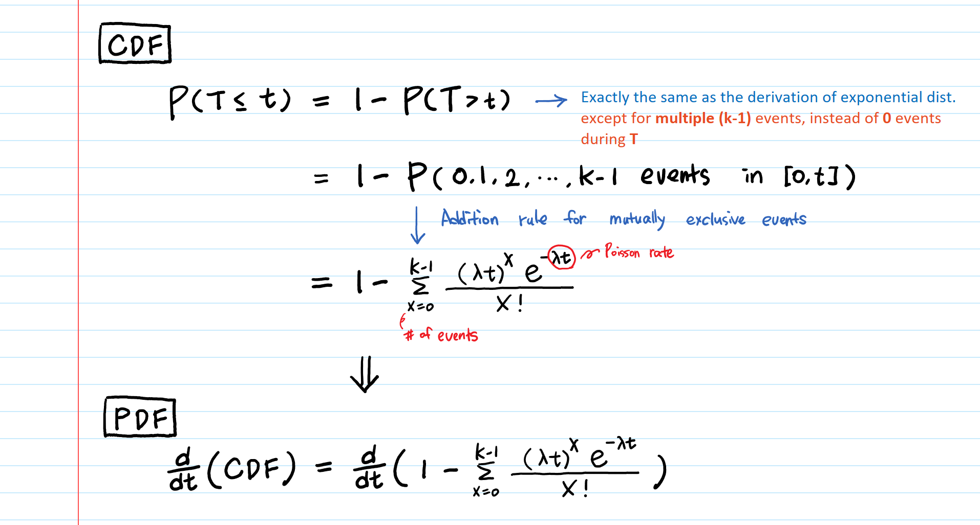

Now, let’s differentiate it.

For easier differentiation, we take out the term (**e^(-λt)**) when x = 0 from the summation.

Image for post

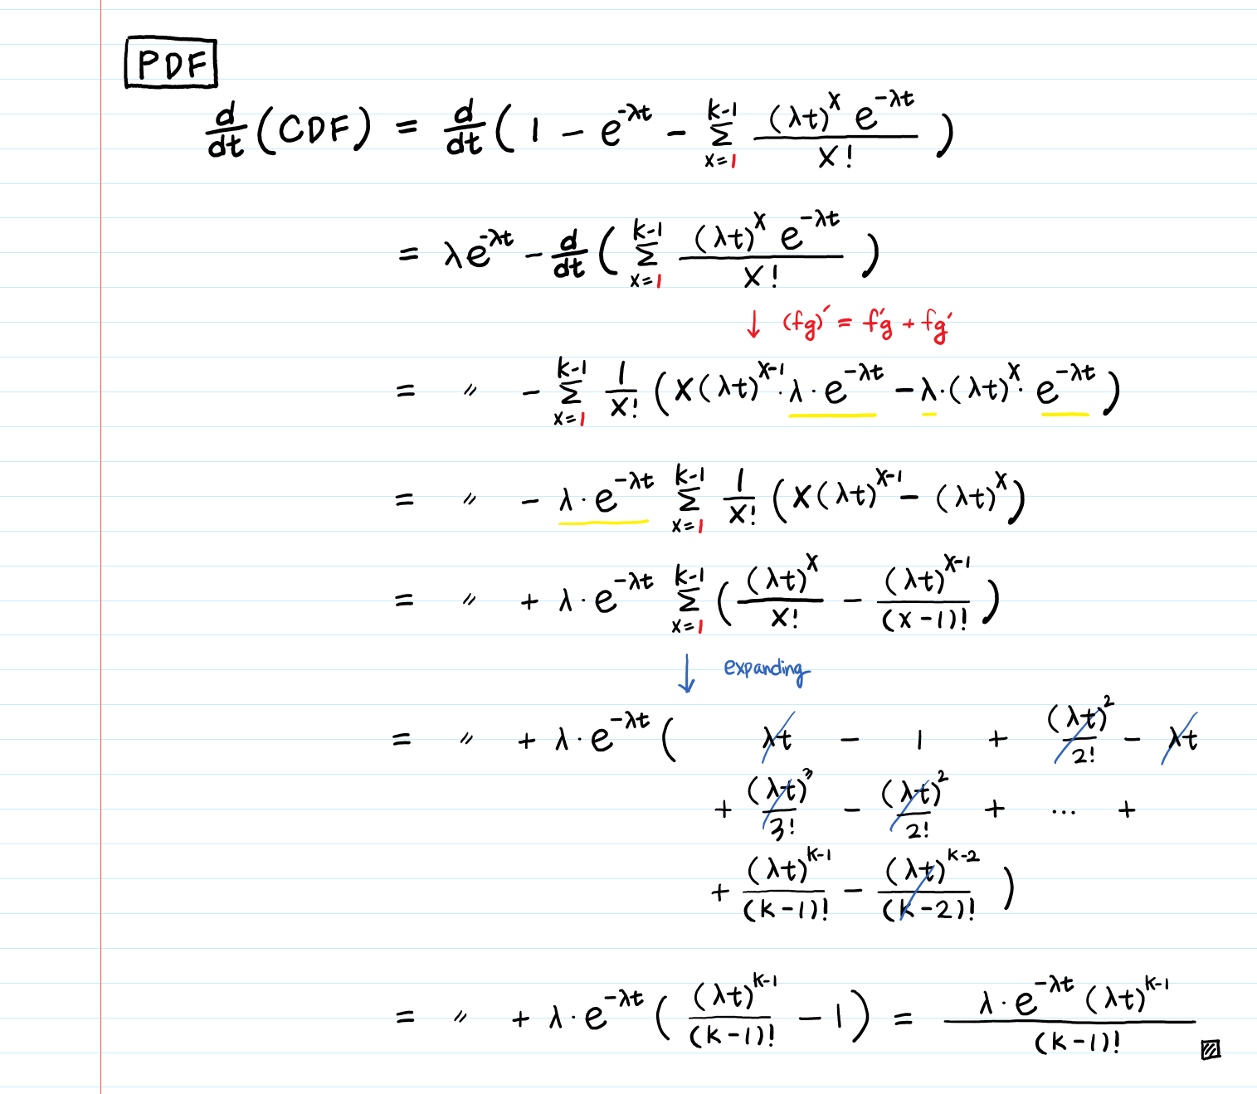

We got the PDF of gamma distribution!

The derivation looks complicated but we are merely rearranging the variables, applying the product rule of differentiation, expanding the summation, and crossing some out.

If you look at the final output of the derivation, you will notice that it is the same as the PDF of Exponential distribution, when **k**=1.

Since **k** is a positive integer (number of **k**events), **𝚪(k) = (k−1)!** where 𝚪 denotes the gamma function. The final product can be rewritten as:

Image for post

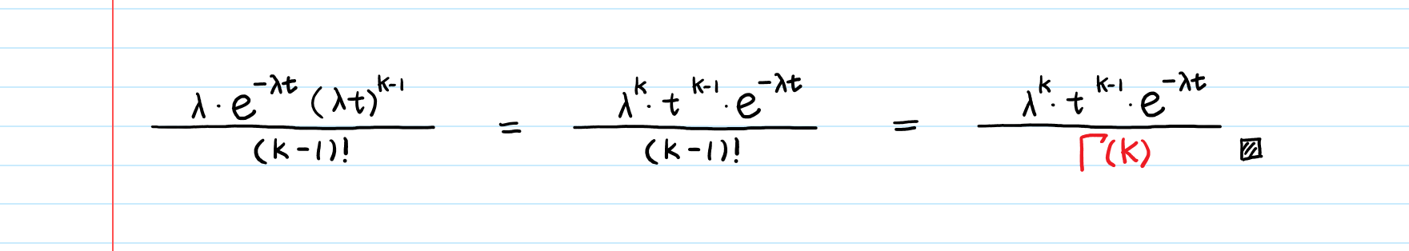

If arrivals of events follow a Poisson process with a rate λ, the wait time until k arrivals follows Γ(k, λ).

**3. Parameters of Gamma: a shape or a scale?!**

There are two aspects of Gamma’s parameterization that confuse us!

Image for post

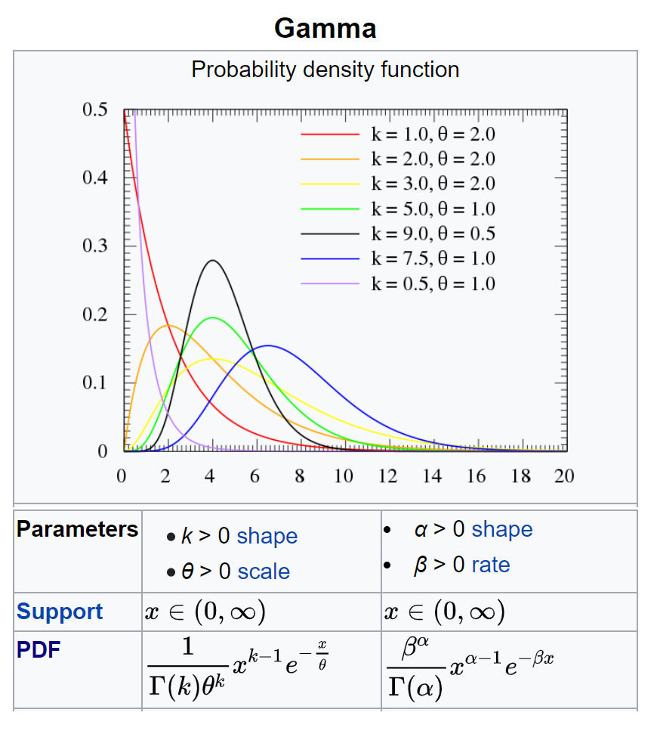

From <https://en.wikipedia.org/wiki/Gamma_distribution>

One is that it has two different parameterization sets — (**k**,**θ**) &(**α**,**β**) — and different forms of PDF. The other is that there is no universal consensus of what the “**scale**” parameter should be.

Let’s clarify this.

The first issue is pretty straightforward to clear up.

For (**α**,**β**) parameterization: Using our notation **k** (the # of events) & **λ** (the rate of events), simply substitute **α** with **k**,**β** with **λ**. The PDF stays the same format as what we’ve derived.  
For **(k, θ)**parameterization**:** **θ**is **a reciprocal of the event rate λ**, which is [the mean wait time](https://towardsdatascience.com/what-is-exponential-distribution-7bdd08590e2a) (the average time between event arrivals).

Even though the PDFs have different formats, both parametrizations generate the same model. Just like in order to define a straight line, some use a slope and a y-intercept, while others use an x-intercept and a y-intercept, choosing one parameterization over another is a matter of taste. In my opinion, using λ as a rate parameter makes more sense, given how we derive both exponential and gamma using the Poisson rate λ. I also found (**α**,**β**) parameterization is easier to integrate.

Second, some authors call **λ** a scale parameter while others call **θ=1/λ** the scale parameter instead. IMHO, a “shape” or a “scale” parameter is really more of a misnomer. I plotted multiple Gamma PDFs with different **k** & **λ**sets (there are infinite parameter choices of **k** and **λ**, thus, there is an infinite number of possible Gamma distributions) and realized both **k** (and **λ) change both “shape” AND “scale”**. Whoever named them seriously could have given more intuitive names such as — the number of events and the Poisson rate!

Seeing is believing! Let’s visualize 🌈

Recap:**k** : **The number of events** for which you are waiting to occur.  
**λ** : **The rate of events** happening which follows the Poisson process.

Image for post

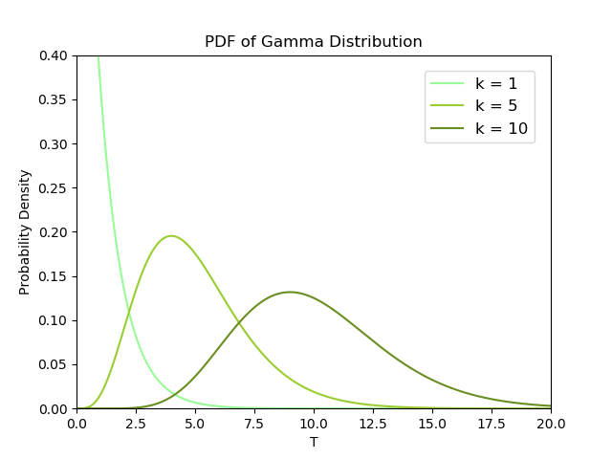

For a fixed rate **λ**, if we wait for more events (**k**) to happen, the wait time (**T**) will be longer.

Image for post

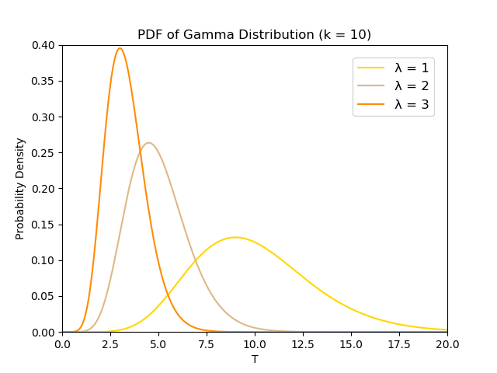

For a fixed number of events **k**, when the event rate **λ**is higher, we wait for a shorter amount of time **T**.

Here is Python code to generate the beautiful plots above. (Plot them yourself and see how the two parameters change the “scale” and “shape”!)

import numpy as np  
from scipy.stats import gamma  
import matplotlib.pyplot as pltdef plot\_gamma\_k():  
 """  
 k : the number of events for which you are waiting to occur.  
 λ : the rate of events happening following Poisson dist.  
 """  
 x = np.linspace(0, 50, 1000)  
 a = 1 # k = 1  
 mean, var, skew, kurt = gamma.stats(a, moments='mvsk')  
 y1 = gamma.pdf(x, a)  
 a = 5 # k = 5  
 mean, var, skew, kurt = gamma.stats(a, moments='mvsk')  
 y2 = gamma.pdf(x, a)  
 a = 10 # k = 15  
 mean, var, skew, kurt = gamma.stats(a, moments='mvsk')  
 y3 = gamma.pdf(x, a)plt.title("PDF of Gamma Distribution")  
 plt.xlabel("T")  
 plt.ylabel("Probability Density")  
 plt.plot(x, y1, label="k = 1", color='palegreen')  
 plt.plot(x, y2, label="k = 5", color='yellowgreen')  
 plt.plot(x, y3, label="k = 10", color='olivedrab')  
 plt.legend(bbox\_to\_anchor=(1, 1), loc='upper right',  
 borderaxespad=1, fontsize=12)  
 plt.ylim([0, 0.40])  
 plt.xlim([0, 20])  
 plt.savefig('gamma\_k.png')  
 plt.clf()def plot\_gamma\_lambda():  
 """  
 k : the number of events for which you are waiting to occur.  
 λ : the rate of events happening following Poisson dist.  
 """  
 a = 10 # k = 10  
 x = np.linspace(0, 50, 1000)  
 lambda\_ = 1  
 mean, var, skew, kurt = gamma.stats(a, scale=1/lambda\_, moments='mvsk')  
 y1 = gamma.pdf(x, a, scale=1/lambda\_)  
 lambda\_ = 2  
 mean, var, skew, kurt = gamma.stats(a, scale=1/lambda\_, moments='mvsk')  
 y2 = gamma.pdf(x, a, scale=1/lambda\_)  
 lambda\_ = 3  
 mean, var, skew, kurt = gamma.stats(a, scale=1/lambda\_, moments='mvsk')  
 y3 = gamma.pdf(x, a, scale=1/lambda\_)plt.title("PDF of Gamma Distribution (k = 10)")  
 plt.xlabel("T")  
 plt.ylabel("Probability Density")  
 plt.plot(x, y1, label="λ = 1", color='gold')  
 plt.plot(x, y2, label="λ = 2", color='burlywood')  
 plt.plot(x, y3, label="λ = 3", color='darkorange')  
 plt.legend(bbox\_to\_anchor=(1, 1), loc='upper right',  
 borderaxespad=1, fontsize=12)  
 plt.ylim([0, 0.40])  
 plt.xlim([0, 20])  
 plt.savefig('gamma\_lambda.png')  
 plt.clf()

Code in ipynb: <https://github.com/aerinkim/TowardsDataScience/blob/master/Gamma%20Distribution.ipynb>

**4. Examples IRL🔥**

We can use the Gamma distribution for every application where the exponential distribution is used — [**Wait time modeling, Reliability (failure) modeling, Service time modeling (Queuing Theory), etc.**](https://towardsdatascience.com/what-is-exponential-distribution-7bdd08590e2a) — because exponential distribution is a special case of Gamma distribution (just plug **1** into **k**).

***[Queuing Theory Example]****You went to Chipotle and joined a line with two people ahead of you. One is being served and the other is waiting. Their service times****S1****and****S2****are independent, exponential random variables with a****mean of 2 minutes****. (Thus the mean service rate is****.5/minute****. If this “rate vs. time” concept confuses you, read*[*this*](https://towardsdatascience.com/what-is-exponential-distribution-7bdd08590e2a)*to clarify.)*

***What is the probability that you wait more than 5 minutes in the queue?***

Image for post

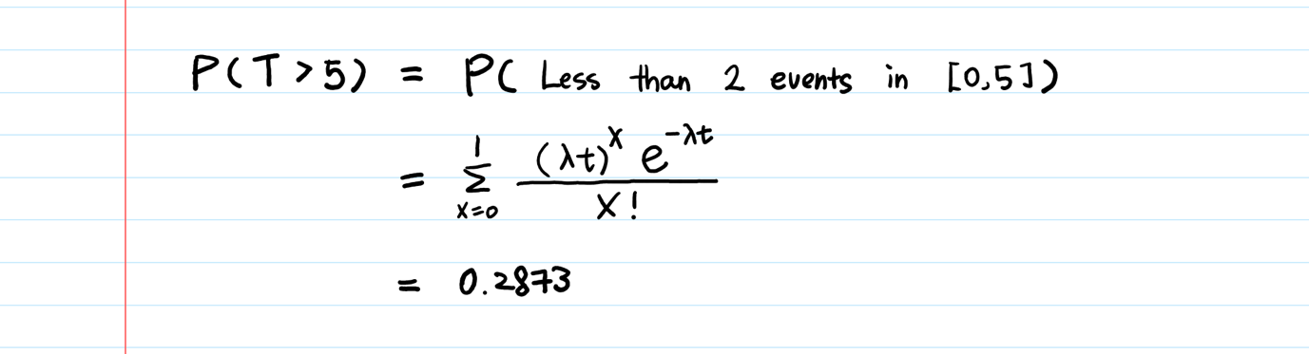

All we did was to plug **t = 5** and **λ = 0.5**into the CDF of the Gamma distribution that we have already derived. This is the same example that we covered in [The Sum of Exponential Random Variables](https://towardsdatascience.com/sum-of-exponential-random-variables-b023b61f0c0f). As you see, we can solve this using Gamma’s CDF as well.

A less-than-30% chance that I’ll wait for more than 5 minutes at Chipotle? I’ll take that!

A few things to note:

1. Poisson, Exponential, and Gamma distribution model different aspects of the same process — the Poisson process.  
   Poisson distribution is used to model the # of events in the future, Exponential distribution is used to predict the wait time **until the very first event**, and Gamma distribution is used to predict the wait time **until the k-th event**.
2. Gamma’s two parameters are both strictly positive, because one is the number of events and the other is the rate of events. They can’t be negative.
3. Special cases of a Gamma distribution

╔═════════════╦══════════════════════╦══════════════════════╗  
║ Dist. ║ **k** ║ **λ** ║  
╠═════════════╬══════════════════════╬══════════════════════╣  
║ Gamma ║ **positive** **real number** ║ positive realnumber ║  
║ Exponential ║ **1** ║"║  
║ Erlang ║ **positive** **integer** ║ " ║  
╚═════════════╩══════════════════════╩══════════════════════╝

The difference between Erlang and Gamma is that in a Gamma distribution, **k** can be a **non-integer (positive real number)**and in Erlang, **k** is **positive integer only.**

**Other intuitive articles that you might like:**

**[Poisson Distribution Intuition (and derivation)](https://towardsdatascience.com/poisson-distribution-intuition-and-derivation-1059aeab90d" \t "_blank)**

[…Why does this distribution exist? (= Why did Poisson invent this?)…](https://towardsdatascience.com/poisson-distribution-intuition-and-derivation-1059aeab90d" \t "_blank)

**[Gamma Function — Intuition, Derivation, and Examples](https://towardsdatascience.com/gamma-function-intuition-derivation-and-examples-5e5f72517dee" \t "_blank)**

[… What kind of functions will connect these dots smoothly and give us factorials of all real values? …](https://towardsdatascience.com/gamma-function-intuition-derivation-and-examples-5e5f72517dee" \t "_blank)

**[What is Exponential Distribution](https://towardsdatascience.com/what-is-exponential-distribution-7bdd08590e2a" \t "_blank)**

[… Is the exponential parameter lambda the same as one in Poisson?…](https://towardsdatascience.com/what-is-exponential-distribution-7bdd08590e2a" \t "_blank)

**[Beta Distribution — Intuition, Examples, and Derivation](https://towardsdatascience.com/beta-distribution-intuition-examples-and-derivation-cf00f4db57af" \t "_blank)**

[… The difference between the Binomial and the Beta is the former models the number of successes, while the latter models the probability of success …](https://towardsdatascience.com/beta-distribution-intuition-examples-and-derivation-cf00f4db57af" \t "_blank)

**[Towards Data Science](https://towardsdatascience.com/?source=post_sidebar--------------------------post_sidebar-)**

A Medium publication sharing concepts, ideas, and codes.

Following

923

8

* [Data Science](https://towardsdatascience.com/tagged/data-science)
* [Machine Learning](https://towardsdatascience.com/tagged/machine-learning)
* [Generative Model](https://towardsdatascience.com/tagged/generative-model)
* [Artificial Intelligence](https://towardsdatascience.com/tagged/artificial-intelligence)

923 claps

8 responses

[[](https://towardsdatascience.com/@aerinykim?source=follow_footer--------------------------follow_footer-)](https://towardsdatascience.com/@aerinykim?source=follow_footer--------------------------follow_footer-)

WRITTEN BY

[**Aerin Kim**](https://towardsdatascience.com/@aerinykim?source=follow_footer--------------------------follow_footer-)

Follow

I’m a Senior Research Engineer at Microsoft and this is my notepad for Applied Math / CS / Deep Learning topics. Follow me on Twitter for more!

[](https://towardsdatascience.com/?source=follow_footer--------------------------follow_footer-)

[**Towards Data Science**](https://towardsdatascience.com/?source=follow_footer--------------------------follow_footer-)

Following

A Medium publication sharing concepts, ideas, and codes.

**More From Medium**

More from Towards Data Science

[Do You Know Python Has A Built-In Database?](https://towardsdatascience.com/do-you-know-python-has-a-built-in-database-d553989c87bd?source=post_recirc---------0------------------)

[Christopher Tao](https://towardsdatascience.com/@qiuyujx?source=post_recirc---------0------------------) in [Towards Data Science](https://towardsdatascience.com/?source=post_recirc---------0------------------)

[Jul 27](https://towardsdatascience.com/do-you-know-python-has-a-built-in-database-d553989c87bd?source=post_recirc---------0------------------) · 6 min read

2.2K

More from Towards Data Science

[Know What Employers are expecting for a Data Scientist Role in-2020](https://towardsdatascience.com/know-what-employers-are-expecting-for-a-data-scientist-role-in-2020-65ad68553cc4?source=post_recirc---------1------------------)

[Shareef Shaik](https://towardsdatascience.com/@shareefshaik1375?source=post_recirc---------1------------------) in [Towards Data Science](https://towardsdatascience.com/?source=post_recirc---------1------------------)

[Jul 26](https://towardsdatascience.com/know-what-employers-are-expecting-for-a-data-scientist-role-in-2020-65ad68553cc4?source=post_recirc---------1------------------) · 9 min read

1.4K

More from Towards Data Science

[Will GPT-3 Kill Coding?](https://towardsdatascience.com/will-gpt-3-kill-coding-630e4518c04d?source=post_recirc---------2------------------)

[Frederik Bussler](https://towardsdatascience.com/@frederikbussler?source=post_recirc---------2------------------) in [Towards Data Science](https://towardsdatascience.com/?source=post_recirc---------2------------------)

[Jul 21](https://towardsdatascience.com/will-gpt-3-kill-coding-630e4518c04d?source=post_recirc---------2------------------) · 5 min read

2.5K

**[Discover Medium](https://medium.com/about?autoplay=1&source=post_page-----55f407423840----------------------)**

Welcome to a place where words matter. On Medium, smart voices and original ideas take center stage - with no ads in sight. [Watch](https://medium.com/about?autoplay=1&source=post_page-----55f407423840----------------------)

**[Make Medium yours](https://medium.com/topics?source=post_page-----55f407423840----------------------)**

Follow all the topics you care about, and we’ll deliver the best stories for you to your homepage and inbox. [Explore](https://medium.com/topics?source=post_page-----55f407423840----------------------)

**[Become a member](https://medium.com/membership?source=post_page-----55f407423840----------------------)**

Get unlimited access to the best stories on Medium — and support writers while you’re at it. Just $5/month. [Upgrade](https://medium.com/membership?source=post_page-----55f407423840----------------------)

[About](https://medium.com/about?autoplay=1&source=post_page-----55f407423840----------------------)

[Help](https://help.medium.com/hc/en-us?source=post_page-----55f407423840----------------------)

[Legal](https://policy.medium.com/medium-terms-of-service-9db0094a1e0f?source=post_page-----55f407423840----------------------)